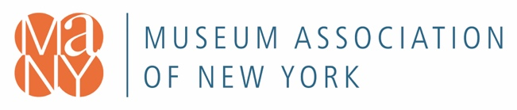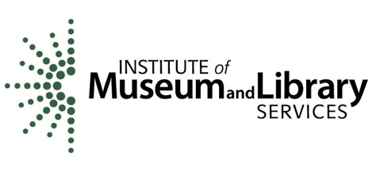

**Building Capacity, Creating Sustainability, Growing Accessibility Application Form**

Please email application to [imlscares@nysmuseums.org](mailto:imlscares@nysmuseums.org) before 5 PM on October 30, 2020

Museums will develop, deliver, and assess two programs; one in partnership with a regional library. Each staff member will commit to 60 hours of training time and 250 hours of program planning, development, and delivery time over the two years.

Participants do not need to be in the same department; cross departmental collaboration is encouraged. No prior experience with technology is necessary. The goal of the program is to give staff the tools and training to virtually reach their communities and raise their profile with audiences beyond their physical locations.

Over the course of this two year project, two staff from each museum will participate in

* three in-person meetings
* at the beginning of Year One,
* at the beginning of Year Two
* at the end of Year Two
* 15 group virtual training meetings
* bi-monthly one-on-one conversations

**Organization**

**Mailing Address**

**Physical address**

*(if different from mailing address)*

**REDC Region**

___Capital Region ___Central NY ___Finger Lakes ___Long Island ___Mid-Hudson

___Mohawk Valley ___New York City ___North Country ___Southern Tier ___Western NY

**Phone Email**

**Website**

**Approval signature of museum director or board chair or letter of support attached.**

**Part A: About Your Museum**

**Mission Statement**

**Collection and/or Exhibition(s) Description (150 words or fewer)**

**Number of Staff**

**Full Time Part Time**

**Does your site offer free public access to Wi-Fi?**

**When did your museum reopen after NY on Pause restrictions were lifted in your region?**

**Organization Budget Size:**

**___**Budget under $24,999

___$25,000 - $49,999

___$50,000 - $99,999

___$100,000 - $499,999

___$500,000 - $999,999

___$1,000,000 - $2,499,999

___$2,500,000 - $4,999,999

___$5,000,000 - $9,999,999

___Budget over $10,000,000

**Organization Type**

**___**Art Museum

___Botanical Garden

___Children’s Museum

___Cultural Center

___Friends Group

___General Museum

___Historic House

___History Museum / Historical Society

___Library / Archives

___Science Museum

___State Park / Historic Site

___National Park / Historic Site

___Town Historian

___University / College Museum

___Wildlife Center

___Other______________________________________________

**Please select which social media channels your museum uses:**

**___**Facebook

___Twitter

___Instagram

___LinkedIn

___YouTube

___SnapChat

___Other________________________________________

**Please confirm your community is located in or serves a high needs school district as designated by NYSED and write your District Name here:**

**________________________________________________________________________________**

*If you are not sure, please check here* [*http://bit.ly/NYSEDneedcategories*](http://bit.ly/NYSEDneedcategories)

**When was the last time your museum conducted a program/exhibition evaluation, what was the project, and what was the evaluation process?**

**Have you ever conducted a virtual program?**

**___Yes ___No**

**If yes, have you used any of the following tools?**

___Zoom

___WebEx

___Google Meet

___Go To Meeting

___Microsoft Teams

___Skype

___FaceTime

___Facebook Live

___YouTube

___Instagram Stories

___Other________________________________________________

**Part B: Project Participants** *(to be filled out by potential project participants)*

**Name**

**Title**

**Phone**

**Email**

**On a scale of 1-10 how tech savvy are you?** *(1 being not savvy and 10 very savvy)*

**1 2 3 4 5 6 7 8 9 10**

**When was the last professional development program you participated in? What was the subject?**

**How long have you been in your current role?**

**Name**

**Title**

**Phone**

**Email**

**On a scale of 1-10 how tech savvy are you?** *(1 being not savvy and 10 very savvy)*

**1 2 3 4 5 6 7 8 9 10**

**When was the last professional development program you participated in? What was the subject?**

**How long have you been in your current role?**

**Part C: Essay Questions** (not to exceed 250 words per question)

**How do you envision using technology to develop a virtual program that focuses on the cultural and racial diversity in your community?**

**What happened the last time you thought a program or an exhibition was going to be successful, but wasn’t? How did you change or improve it? What would you do differently if given the opportunity to do it again?**

**How did your museum reach and engage your audience during NY on Pause?**