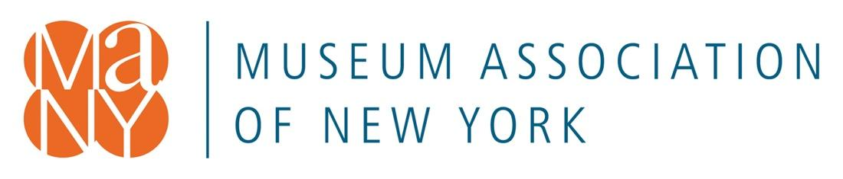

Memo in Support of S.8934 (Cooney)/A.9710 (Barrett)

The Museum Study Act

The Museum Association of New York, the only statewide museum service organization with more than 700 member museums, historical societies, zoos, botanical gardens, and aquariums, wholeheartedly supports S.8934/A9710, "An act in relation to conducting a study of public and private museums in New York state."

Museums are inextricably linked to New York State's identity, economy, and history. Too many operate in a culture of scarcity, struggling to pay bills and wondering each year how they will keep their doors open. Museums need support to ensure the protection of their collections, to strengthen their roles as community education partners chartered by the SED, and to grow their role as economic engines generating $5.37B to the state's economy.

The proposed study will identify and gather data about all museums in the state including information on size, hours of operation, visitor statistics, funding sources and amounts, and the subjects of their collections. It will help communities, legislative representatives, and individual supporters learn about the missions, audiences, and funding needs of our state's 1400+ museums.

It will provide information about the sufficiency of public and private funding sources, inform policy making, and grow public awareness. The benefits, shortfalls, and consequences of the different sources of state support will be revealed and systems to best ensure equitable distributions of funds regardless of discipline, budget size, or location can be recommended based on the data gathered.

The hundreds of responses to our State of NYS Museums and COVID-19 impact studies helped the Museum Association of New York gain attention and support for relief funding that kept many of our museums functional in the past two years. The study proposed in S.8934/A9710 will help them carry out their missions and serve their audiences into the future.

